**INTERNET CONTROL MESSAGE PROTOCOL**

### A Third Year Computer Communication Network MiniProject Report

Submitted in partial fulfillment of the requirements of the degree of

### Bachelor Of Engineering

By

ROHIT GUPTA 20

BAZAID HAFIZI 21

DARSHAN KADLAG 22

NEEDHI KAMBLE 23

## Supervisor:

**Ms. Hemlata Mote**



# Department of Electronics and Telecommunication Don Bosco Institute of Technology

**University of Mumbai**

## 2022 **-** 2023



### Don Bosco Institute of Technology

**(Affiliated to the University of Mumbai) Premier Automobiles Road, Kurla, Mumbai – 400070**

**CERTIFICATE**

This is to certify that the project entitled “Internet Control Message Protocol” is a bonafide work of

|  |  |
| --- | --- |
| ROHIT GUPTA BAZAID HAFIZI  DARSHAN KADLAG  NEEDHI KAMBLE | 20  21  22  23 |

submitted to the University of Mumbai in partial fulfillment of the requirement for the award of the degree of **“Undergraduate”** in **“Bachelor of Engineering”**



### Don Bosco Institute of Technology

**(Affiliated to the University of Mumbai) Premier Automobiles Road, Kurla, Mumbai – 400070**

### MiniProject Report Approval for CCN TE MINIPROJECT

This project report entitled **‘TELNET.’** by**, Rohit Gupta, Bazaid Hafizi, Darshan Kadlag, Needhi Kamble** approved for the degree of **Bachelor of Engineering in Electronics & Telecommunication.**

### Declaration

I declare that this written submission represents my ideas in my own words and where others’ ideas or words have been included,I

have adequately cited and referenced the original sources. I also declare that I have adhered to all principles of academic honesty and integrity and have not misrepresented or fabricated or falsi-fied any idea / data / fact / source in my submission. I understand that any violation of the above will be cause for disciplinary actionby the Institute and can also evoke penal action from the sources which have thus not been properly cited or from whom proper per-mission has not been taken when needed.

### Rohit Gupta Bazaid Hafizi

**Darshan Kadlag Needhi Kamble**

# ACKNOWLEDGEMENT

## A project is a teamwork which involves the contribution of many people. We would like to thank everyone who have contributed by taking interest in our work and motivating us all the way through. Our sincere thanks to our project guide Prof. Hemlata Mote, for motivating, co-operating and guiding us throughout the project work, with his effective skills and huge knowledge base. We would like to thank Ms. Namita Agarwal ma’am, Head of Department for their continuous valuable guidance, support, suggestions and their precious time in every possible way throughout the project activity.

**ABSTRACT**

Telnet is a network protocol used to establish a remote connection between two computers over the internet or a local network. It operates on top of the Transmission Control Protocol (TCP) and allows a user to log in to a remote computer and access its resources as if they were directly connected to the computer's console. Telnet is still used in some situations, but it has largely been replaced by more secure protocols like Secure Shell (SSH) due to its vulnerability to interception and unauthorized access.

**CONTENTS**

|  |  |
| --- | --- |
| **Chapter 1:**  Introduction  What is TELNET?  TELNET protocol  Concept of NVT?  How to connect Remote Computer Using Telnet  Tips for use TELNET | **Hat**  **08**  **08**  **09**  **09**    **10**  **10** |
| **Chapter 2:**  Design in Cisco Packet Tracer | **11** |
| **Chapter 3:**  Description | **12** |
| **Chapter 4:**  Simulation/ circuit diagram in Cisco Packet Tracer | **13** |
| **References** | **21** |

# CHAPTER 1

### INTRODUCTION

### Telnet is a network protocol that has been in use since the early days of the internet. It was developed in 1969 and became one of the first protocols used for remote login and terminal emulation. Telnet enables a user to establish a remote connection to a server or host system and interact with it through a command-line interface (CLI).

### Telnet uses the Transmission Control Protocol (TCP) to establish a reliable and secure connection between the client and the server. Once connected, the user can execute commands on the remote system, transfer files, and access resources as if they were directly connected to the console of the remote machine.

### While Telnet has been widely used for many years, its use has declined in recent years due to security concerns. The protocol transmits all data, including passwords, in plain text, which makes it vulnerable to interception and unauthorized access. As a result, more secure protocols like SSH have largely replaced Telnet in modern network environments.

### What is TELNET?

### Telnet is a network protocol used to virtually access a computer and to provide a two-way, collaborative and text-based communication channel between two machines.

### It follows a user command Transmission Control Protocol/Internet Protocol (TCP/IP) networking protocol for creating remote sessions.

### TELNET enables the establishment of a connection to a remote system in such a way that the local terminal appears to be a terminal at the remote system.

### In other words, it allows the user to log on to a remote computer. After logging on user can use the services available on the remote computer and transfer the results back to the local computer.

### TELNET protocol?

The Telnet Protocol (TELNET) provides a standard method for terminal devices and terminal-oriented processes to interface.

TELNET is commonly used by terminal emulation programs that allow you to log into a remote host. ...

TCP/IP implements TELNET in the tn, telnet, or tn3270 user commandsnetwork. It enables devices to communicate with each other by identifying the physical address of the intended recipient.

ARP is used by network devices such as routers, switches, and computers to discover and maintain the mapping of IP addresses to MAC addresses. It allows devices to communicate with each other at the data link layer of the OSI model, which is the second layer in the networking stack.

ARP is a critical protocol in enabling communication between devices on a network, and it is used extensively in various network applications and services such as DHCP (Dynamic Host Configuration Protocol), which assigns IP addresses to devices, and NAT (Network Address Translation), which enables multiple devices to share a single IP address.

### Concept of NVT?

The Network Virtual Terminal (NVT) is a protocol that defines a standard virtual terminal interface between a Telnet client and a Telnet server. The NVT provides a common framework for communication between the two systems, allowing them to exchange information and commands in a standardized way.

The NVT protocol defines a set of control characters that are used to specify actions such as moving the cursor, clearing the screen, and changing the color of text. These control characters are transmitted over the Telnet connection as ASCII codes, allowing the remote system to interpret them and perform the appropriate actions.

One of the key benefits of the NVT protocol is that it provides a standard interface that is independent of the physical terminal used by the client or server. This allows Telnet to be used with a wide range of different terminal types and operating systems, making it a flexible and versatile tool for remote access and administration.

**How to connect remote computer using TELNET**

* Step 1:- Install a telnet program (client) on your computer.
* Step 2:- Open your telnet program.
* Step 3:- Enter the telnet address in the address box. Click OK.
* Step 4:- Enter your login ID.

Step 5:- Once you re logged in, the procedure varies depending on how the host been set up

**Tips for use TELNET**

1. You may be able to access your telnet program directly from your browser.
2. Some telnet programs require a colon between “telnet” and the address.
3. Telnet is typically used to turn your computer into a terminal

# Chapter 2

**DESIGN IN CISCO PACKET TRACER**

1. Assembling The Client PC and Their Respective IP
2. Assembling Switches

## Assembling Routers

1. Establishing the Wires

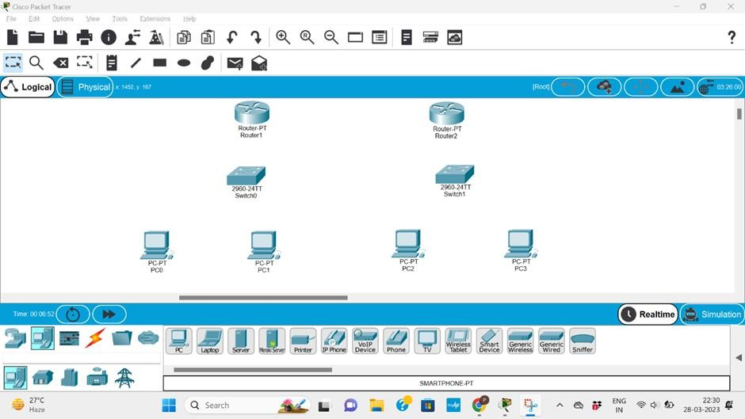

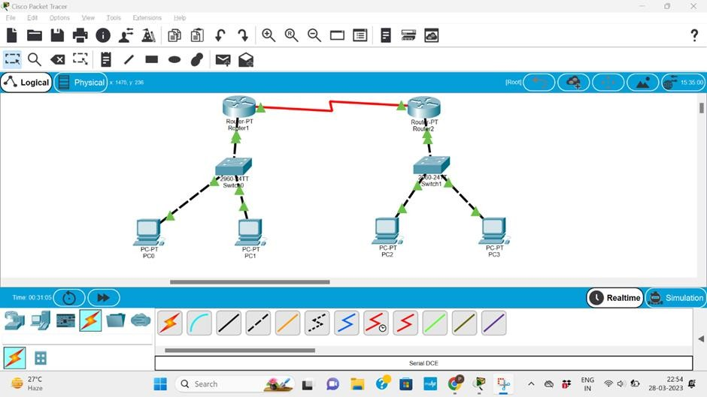

### Chapter-3 Description

Here, we have taken 2 routers for implementing ICMP. And we have taken two different clients to configure with each other. The one client is set of PC of Class A ( 10 series ) and other is Class C (192 series) . As we know that Router is used as connecting device when our aim is to configure the two different network ids.

So we are going to place our connecting devices. After that we have assigned the IP’s to the respective client PC’s. For connecting the devices with each other we have used copper cross wire cable as Fast Ethernet.

For configuring the IP addresses of the router we have configured IP for fast Ethernet. Default gateway of client PC is going to be the same IP of the router. Since both the routers are communicating with different networking id, we need to configure the connection between two routers with different networking id and for our ease we have given 11.0.0.1 .

Since our router R1 has the information about the 10 series as it is connected to it and 11 series we configured it, our main aim is to establish the communication between router R1 having 10 series and router R2 having 192 series, we are assigning the static network ip as 192.168.0.0 and subnet mask of 255.255.255.0 The next hop is which where it is getting communicating with that is 11.0.0.2 Same goes with other router.

After configuring router with this all, router has information about 10 series, 11 series and 192 series.

To check if both the client PCs with different IPS can communicate, we will simply write a ping command in the command prompt for the client PC. The command ‘ping 192.168.0.2’ will ping the client pc 2.Getting reply will signify the both PC are in connection.

Now because we want to observe the ICMP we will apply filter as ICMP in the simulation. For sending the packet we will first ping the desired client pc. After that with Capture/Forward we will send our packet to the desired destination.

# Chapter 4

### SIMULATION/CIRCUIT DIAGRAM IN CISCO PACKATE TRACER

1. Sending Packet to Sender Client
2. Packet in System.
3. Packet Reaching Destination Client
4. Final Output

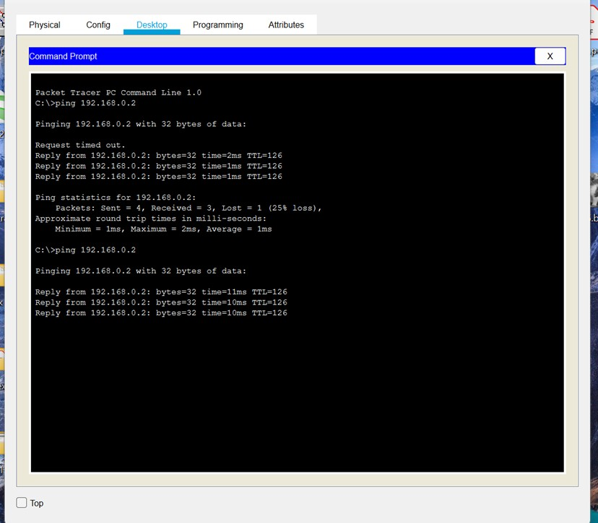

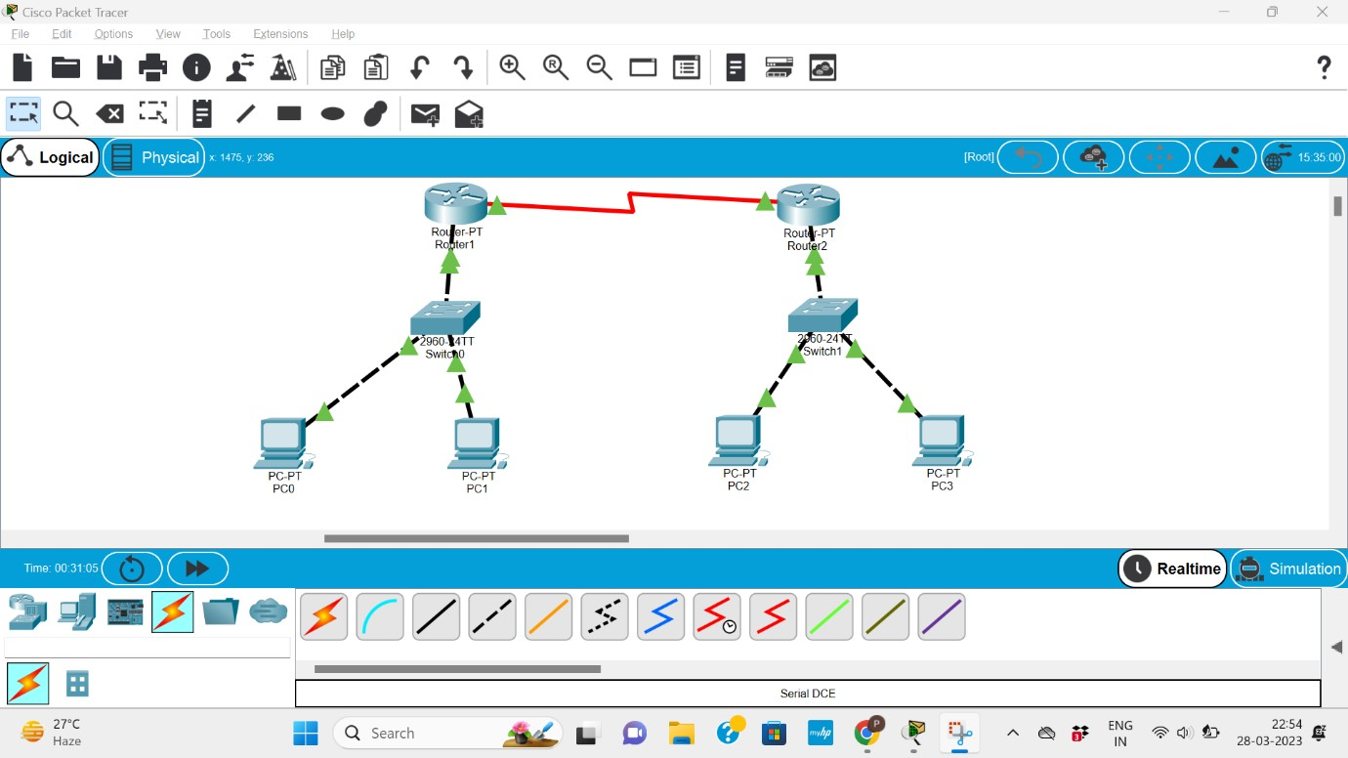

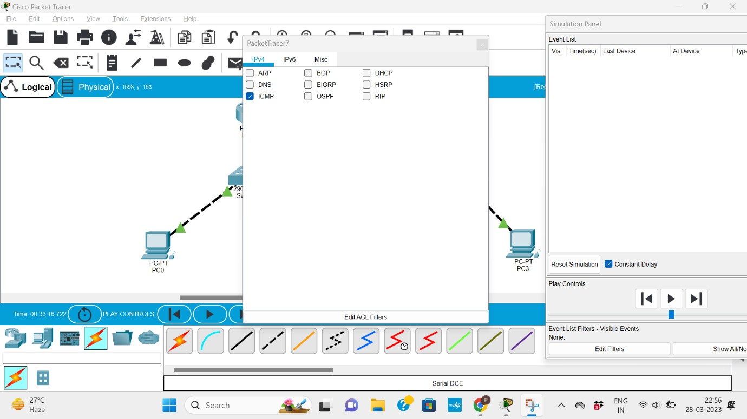

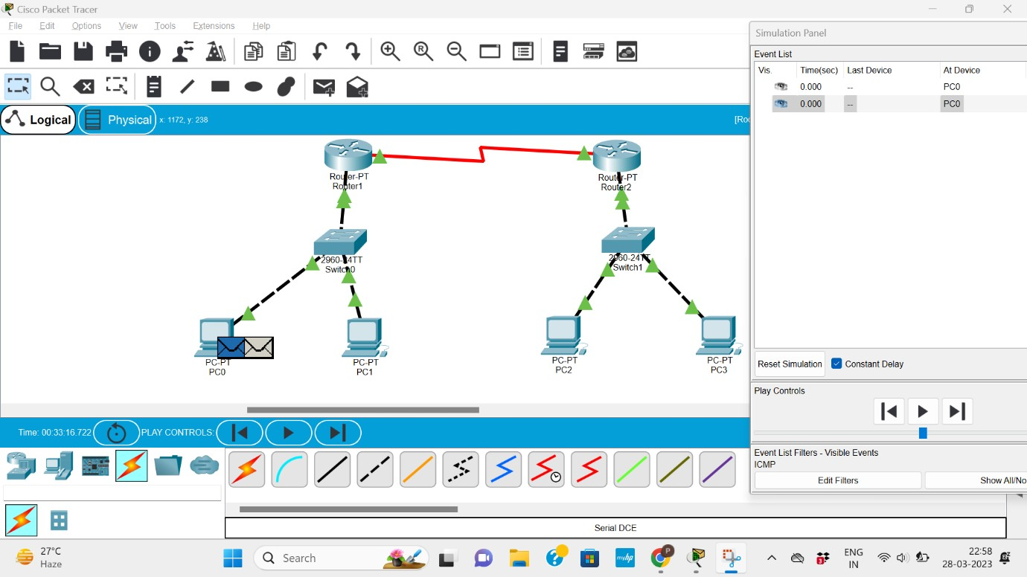

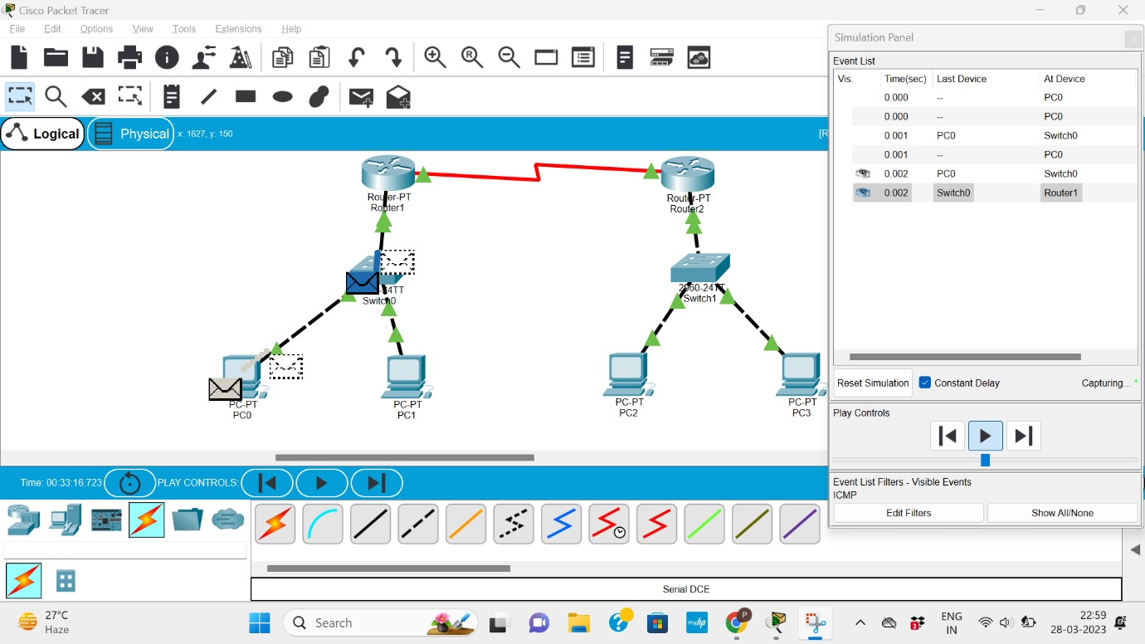

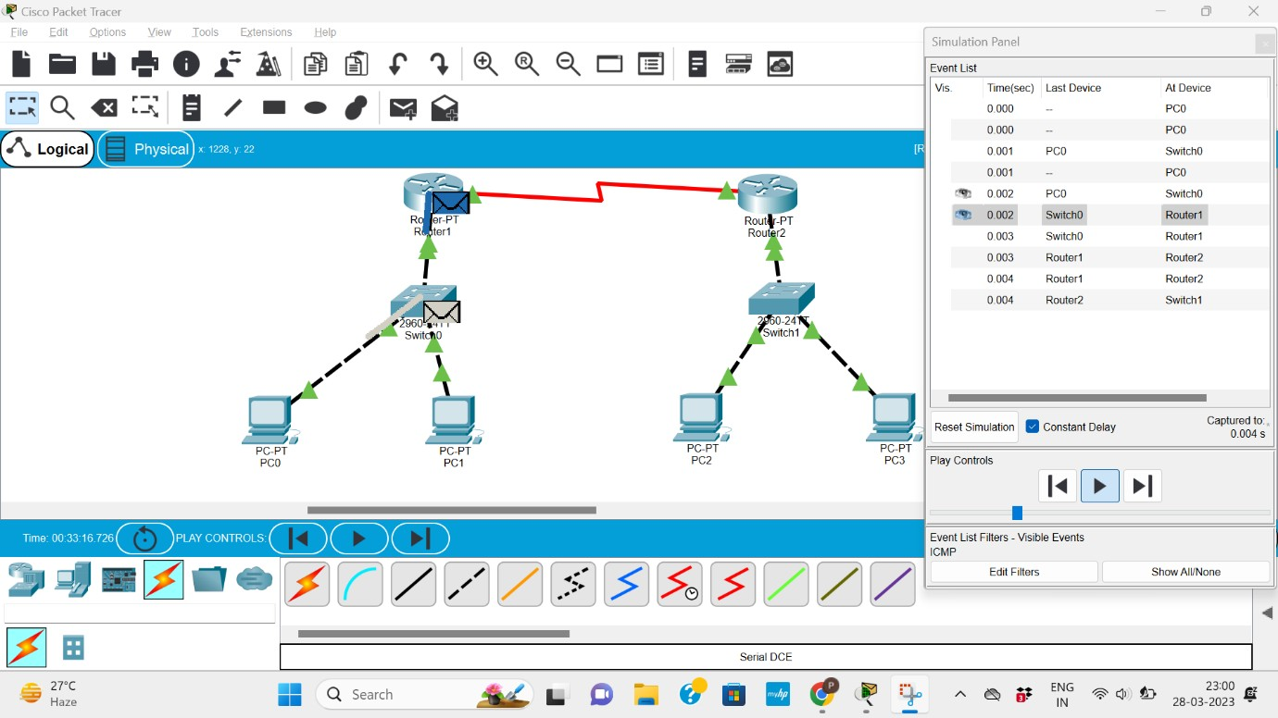

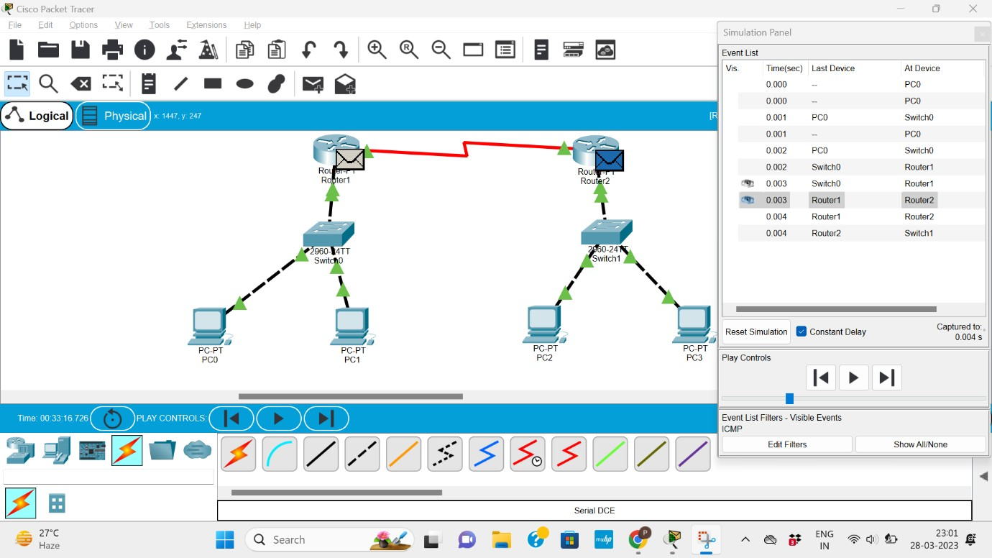

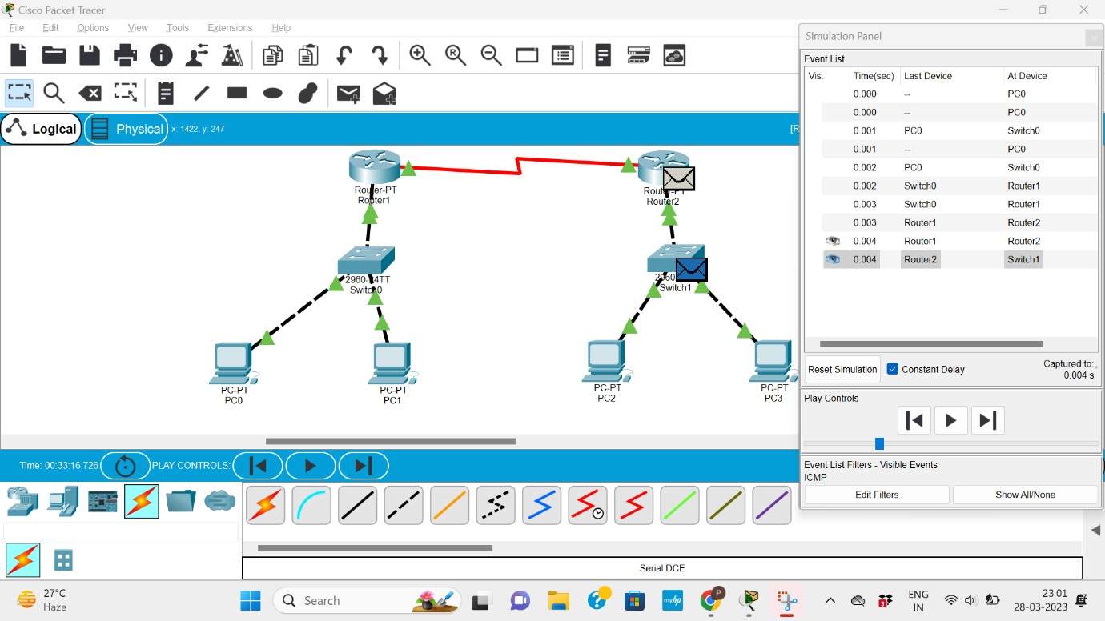

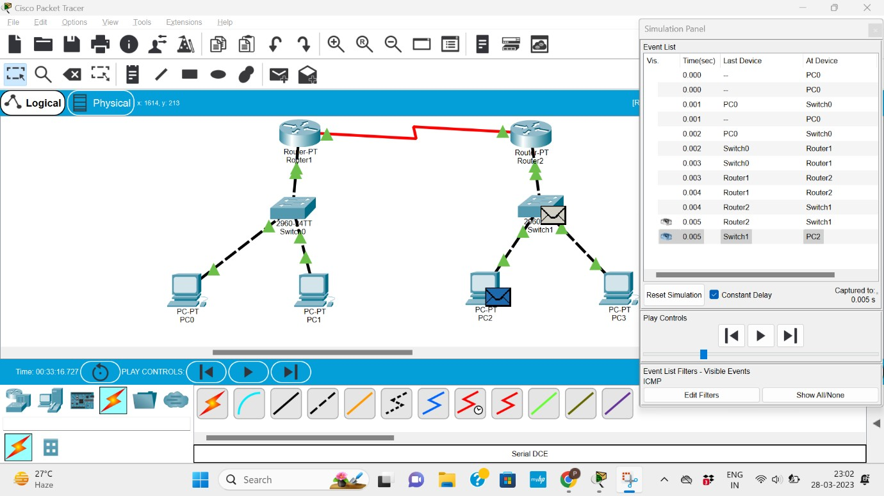

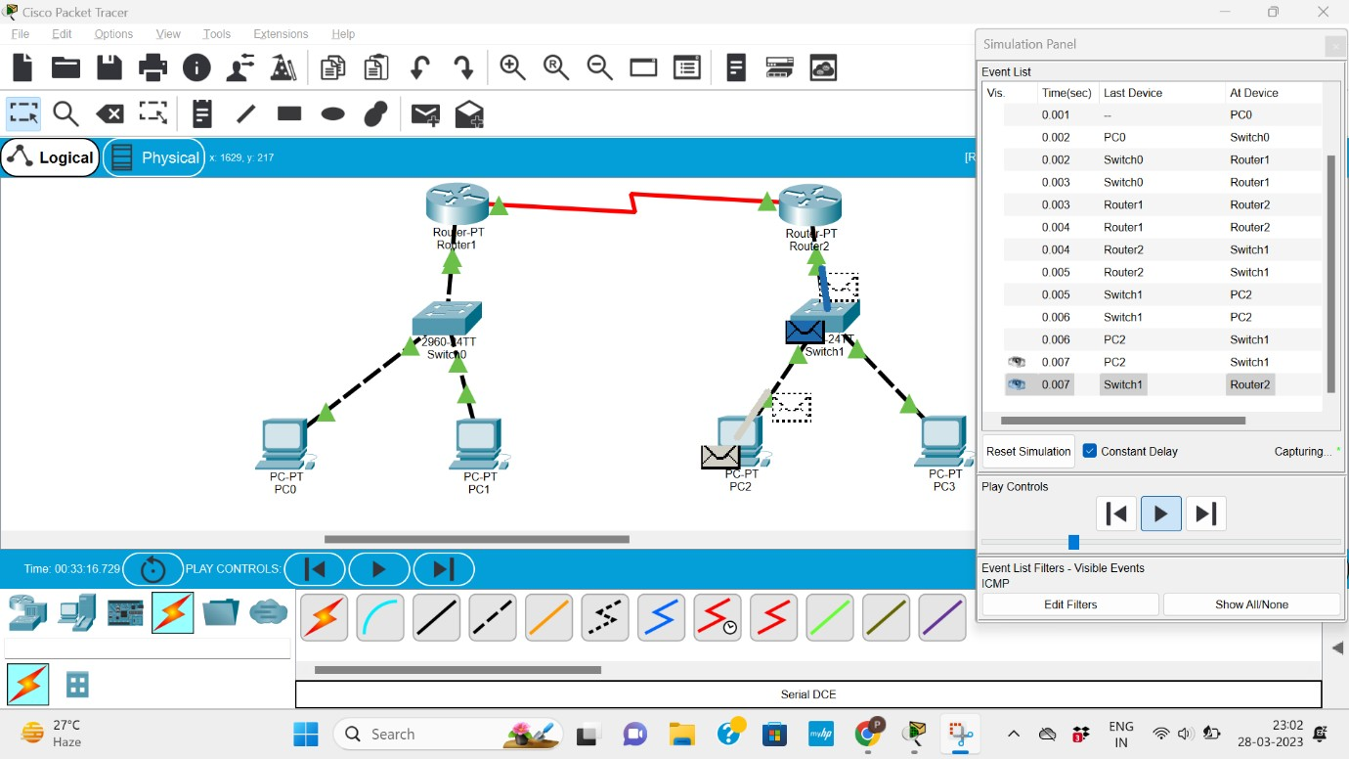

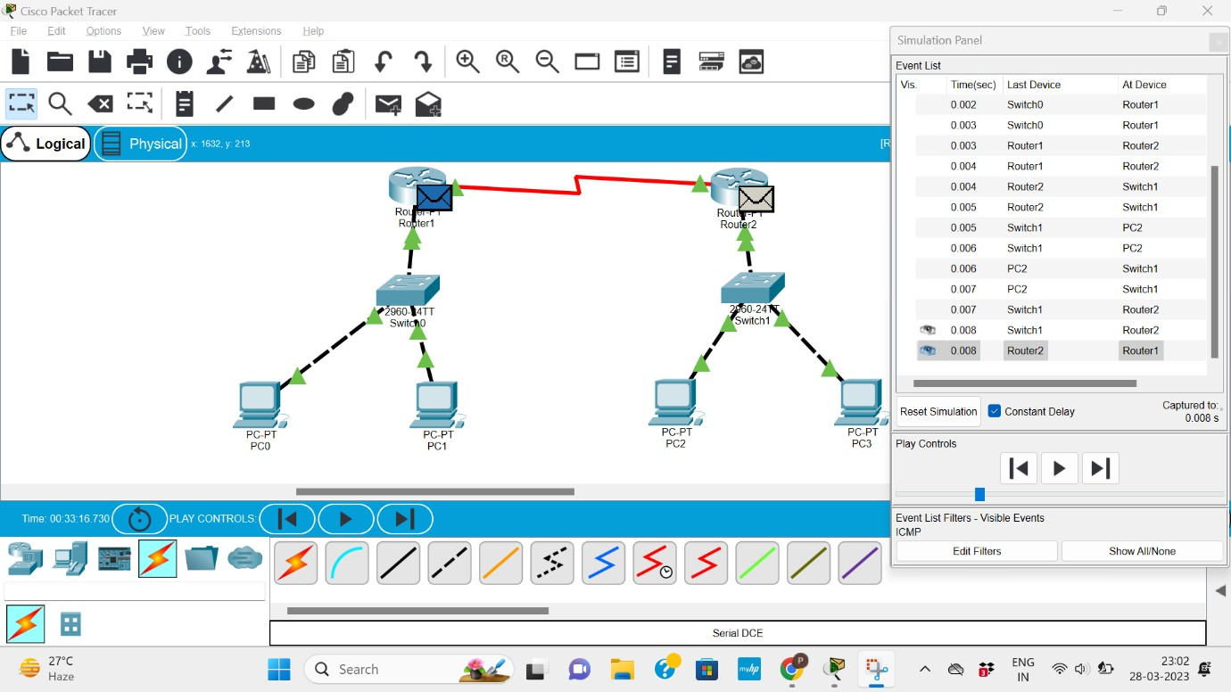

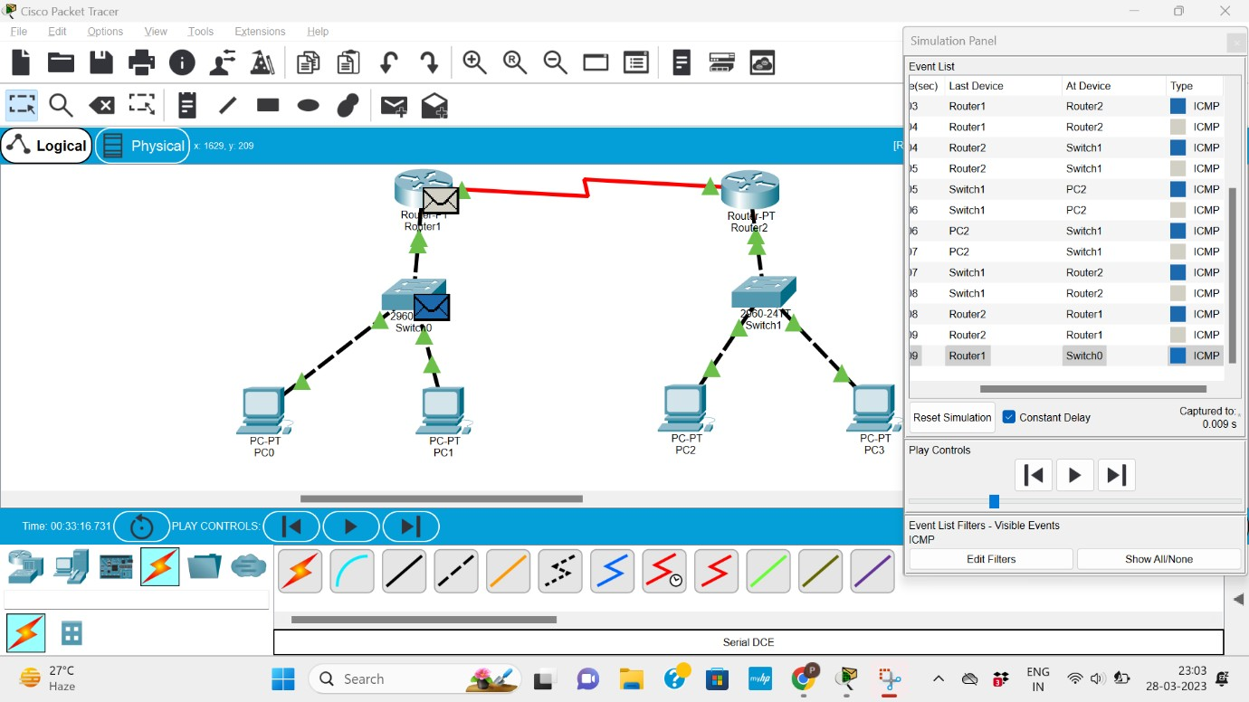

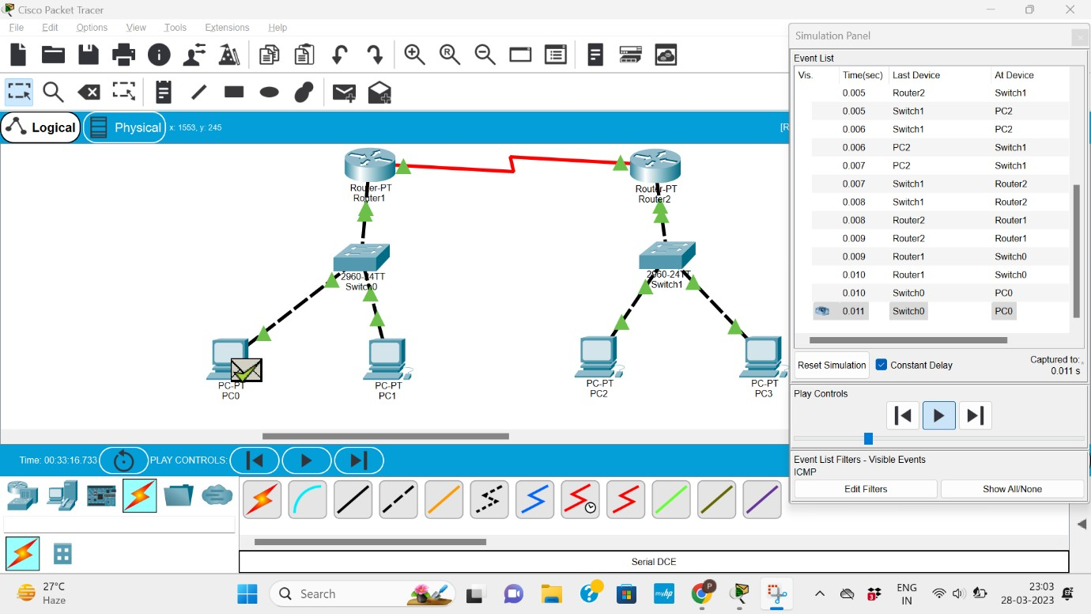

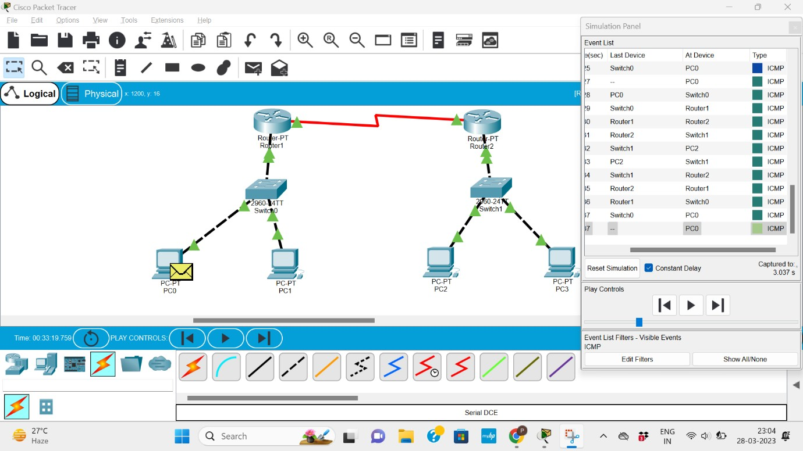

### References

Youtube- https://[www.youtube.com/watch?v=2LkZ66zKTtU&ab](http://www.youtube.com/watch?v=2LkZ66zKTtU&ab)

Extra Hop- <https://www.extrahop.com/resources/protocols/icmp/>

Research Gate- [https://www.researchgate.net/publication/2449272_Internet_Control_Message_](https://www.researchgate.net/publication/2449272_Internet_Control_Message_Protocol) [Protocol](https://www.researchgate.net/publication/2449272_Internet_Control_Message_Protocol)

NPTEL-

[https://archive.nptel.ac.in/content/storage2/courses/downloads_new/106105160/](https://archive.nptel.ac.in/content/storage2/courses/downloads_new/106105160/noc) [noc](https://archive.nptel.ac.in/content/storage2/courses/downloads_new/106105160/noc)